Autonomous University Robot Assistant
Michael Fritzer, Muhammed Faseeh,
David Haybarger, Kevin Lee

Interface Control Document

REVISION – 1
30 September 2025
Interface Control Document
for
Autonomous University Robot Assistant

Prepared by:

David Haybarger 09/30/2025
_____________________________
Author Date

Approved by:

Michael Fritzer 10/04/2025
_____________________________
Project Leader Date

Byung-Jun Yoon XX/XX/2025
_____________________________
Professor Date

Fahrettin Ay XX/XX/2025
_____________________________
T/A Date

Change Record
Rev. | Date | Originator | Approvals | Description
1 | 09/30/2025 | Michael Fritzer,  Muhammed Faseeh,  David Haybarger,  Kevin Lee | Michael Fritzer,Fahrettin Ay,Byung-Jun Yoon | Draft Release

Table of Contents
Table of Contents 3
List of Tables 4
List of Figures 4
1. Overview ................................................................................................................................. 5
2. References and Definitions .................................................................................................. 5
2.1. References ................................................................................................................ 5
2.2. Definitions ................................................................................................................. 5
3. Physical Interface................................................................................................................... 7
3.1. Weight ....................................................................................................................... 7
3.1.1. Main Processing Unit and Power System .................................................. 7
3.1.2. Robotic System .......................................................................................... 7
3.1.3 UI Components .......................................................................................... 7
3.1.4 3D Printed Shell ......................................................................................... 7
3.2. Dimensions ............................................................................................................... 8
3.2.1. Main Processing Unit and Power System .................................................. 8
3.2.2. Robotic System .......................................................................................... 8
3.2.3 UI Components .......................................................................................... 8
3.2.4 3D Printed Shell ......................................................................................... 8
3.3. Mounting Locations ................................................................................................... 9
4. Thermal Interface ................................................................................................................... 9
5. Electrical Interface ............................................................................................................... 10
5.1. Primary Input Power ............................................................................................... 10
5.1.1. Main Power System.................................................................................. 10
5.1.2. Charging and Protection........................................................................... 10
5.2. User Control Interface ............................................................................................. 10
5.3. Voltage and Current Levels ..................................................................................... 11
5.3.1. Maximum Values ...................................................................................... 11
5.3.2. Stand-by Values ....................................................................................... 11
5.4. Signal Interfaces ..................................................................................................... 12
6. Communications / Device Interface Protocols ................................................................. 12
6.1. Wireless Communications ...................................................................................... 12
6.1.1. Wi-Fi ......................................................................................................... 12
6.1.2. Bluetooth .................................................................................................. 12
6.2. Host Device ............................................................................................................ 12
6.3. Video Interface ........................................................................................................ 12
6.4. Device Peripheral Interface .................................................................................... 12

List of Tables

Table 1: Main Processing Unit and Power System Weight…………………………………………. 7
Table 2: Robotic System Weight……………………………………………………………………….. 7
Table 3: UI Components Weight……………………………………………………………………….. 7
Table 4: 3D Printed Shell Weight………………………………………………………………………. 7
Table 5: Main Processing Unit and Power System Dimensions……………………………………. 8
Table 6: Robotic System Dimensions…………………………………………………………………. 8
Table 7: UI Components Dimensions…………………………………………………………………. 8
Table 8: 3D Printed Shell Dimensions………………………………………………………………… 8
Table 9: Maximum Voltage and Current Levels………………………………………………………11
Table 10: Stand-by Voltage and Current Levels……………………………………………………...11
List of Figures

Figure 1: Reference of ARUA Deployment Location………………………………………………… 9
Figure 2: Electrical Interface Diagram……………………………………………………………10

Overview
The following document for the Autonomous University Robot Assistant (ARUA) details the interfaces between its hardware, software, and peripheral subsystems. This document specifies the physical, thermal, electrical, and communication requirements necessary for integration of the robot’s components. It ensures subsystem compatibility and provides a reference for future scaling, maintenance, and troubleshooting.

References and Definitions

References
Refer to section 2.2 of the Functional System Requirements document.

Definitions
CCA Circuit Card Assembly
mA Milliamp
mW Milliwatt
MHz Megahertz (1,000,000 Hz)
TBD To Be Determined
BIT Built-In Test
CCA Circuit Card Assembly
EMC Electromagnetic Compatibility
EMI Electromagnetic Interference
EO/IR Electro-optical Infrared
FDIR Failure Detection, Isolation, and Recovery
FOR Field of Regard
FOV Field of View
GPS Global Positioning System
GUI Graphical User Interface
Hz Hertz
ICD Interface Control Document
kHz Kilohertz (1,000 Hz)
LCD Liquid Crystal Display
LED Light-emitting Diode
mA Milliamp
MHz Megahertz (1,000,000 Hz)
MTBF Mean Time Between Failure
MTTR Mean Time To Repair
mW Milliwatt
PCB Printed Circuit Board
RMS Root Mean Square
TBD To Be Determined
TTL Transistor-Transistor Logic
USB Universal Serial Bus
VME VERSA-Module Europe
TA Teaching Assistant
AURA Autonomous University Robot Assistant
AI Artificial Intelligence
GPT Generative Pretrained Transformer
LLM Large Language Model
NLP Natural Language Processing
RAG Retrieval Augmented Generation
PSU Power Supply Unit
SAM Segment Anything Model
SOP Standard Operating Procedure
STT Speech-to-Text
TTS Text-to-Speech
UI User Interface
ESP32 Microcontroller responsible for wireless and low level I/O
Jetson Orin Nano Embedded AI computer responsible for processing and interface
PWM Pulse Width Modulation
UART Universal Asynchronous Receiver/Transmitter
GPIO General Purpose Input/Output pins
ICD Interface Control Document
MCU Motor Control Unit

Physical Interface

Weight
3.1.1. Main Processing Unit and Power System
Component | Weight | Number of Items | Total Weight
Jetson Orin Nano | 222.26g | 1 | 222.26g
Battery Power Supply | TBD | 1 | TBD
Custom Power PCB | TBD | 1 | TBD
Table 1: Main Processing Unit and Power System Weight
3.1.2. Robotic System
Component | Weight | Number of Items | Total Weight
Servo Motors | 62g | 3 | 186g
ESP32 MCU | TBD | 1 | TBD
Servo Microcontroller | 9g | 1 | 9g
Table 2: Robotic System Weight
3.1.3. UI Components
Component | Weight | Number of Items | Total Weight
Digital Screen | TBD | 1 | TBD
Camera | TBD | 1 | TBD
Microphone | TBD | 1 | TBD
Table 3: UI Components Weight
3.1.4. 3D Printed Shell
Component | Weight | Number of Items | Total Weight
Body | TBD | 1 | TBD
Arms | TBD | 2 | TBD
Table 4: 3D Printed Shell Weight

Dimensions
3.2.1. Dimensions of Main Processing Unit and Power System
Component | Length | Width | Height
Jetson Orin Nano | 100mm | 80.5mm | 48mm
Battery Power Supply | TBD | TBD | TBD
Custom Power PCB | TBD | TBD | TBD
Table 5: Main Processing Unit and Power System Dimensions
3.2.2. Dimensions of Robotic System
Component | Length | Width | Height
Servo Motors | TBD | TBD | TBD
ESP32 MCU | TBD | TBD | TBD
Servo Microcontroller | 62.5mm | 25.4mm | 3mm
Table 6: Robotic System Dimensions
3.2.3. Dimensions of UI Components
Component | Length | Width | Height
Digital Screen | TBD | TBD | TBD
Camera | TBD | TBD | TBD
Microphone | TBD | TBD | TBD
Table 7: UI Components Dimensions
3.2.4. Dimensions of 3D Printed Shell
Component | Length | Width | Height
Body | TBD | TBD | TBD
Arms | TBD | TBD | TBD
Table 8: 3D Printed Shell Dimensions

Mounting Locations
The Autonomous University Robot Assistant (ARUA) will be primarily deployed in university laboratory environments such as electrical engineering teaching labs. The system will be positioned near or on student workbenches where it has access to both power outlets and wireless connectivity for integration with the campus network.

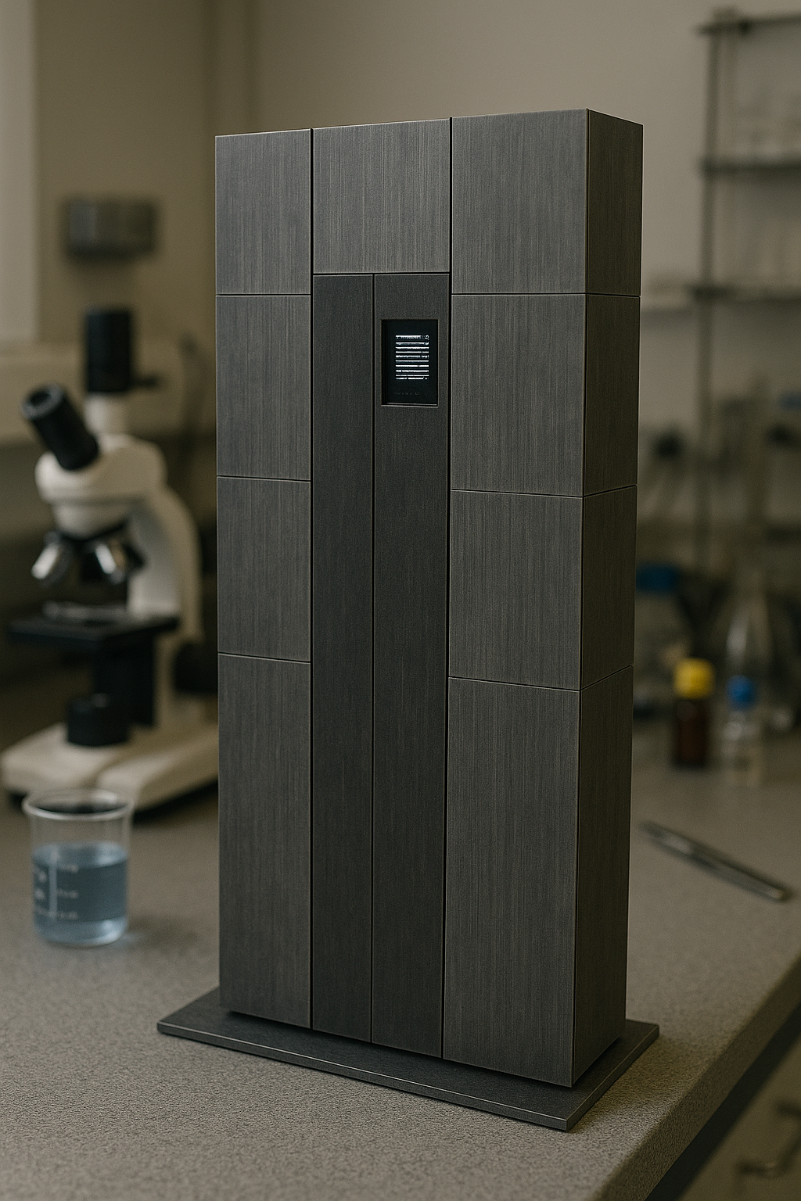
Figure 1: Reference of ARUA Deployment Location

Thermal Interface
The Jetson Orin Nano will require a heat sink and optional fan to ensure reliable performance during extended computation. While the ESP32 microcontroller and motor driver circuits will also be exposed to similar lab conditions, their thermal output is minimal and does not require dedicated cooling. Because the Jetson Orin Nano is responsible for the majority of AI processing and higher power consumption, it is the primary component at risk of overheating. Proper ventilation slots will be included in the enclosure, and a small cooling fan may be added to maintain stable operating temperatures during long-duration lab sessions.

Electrical Interface
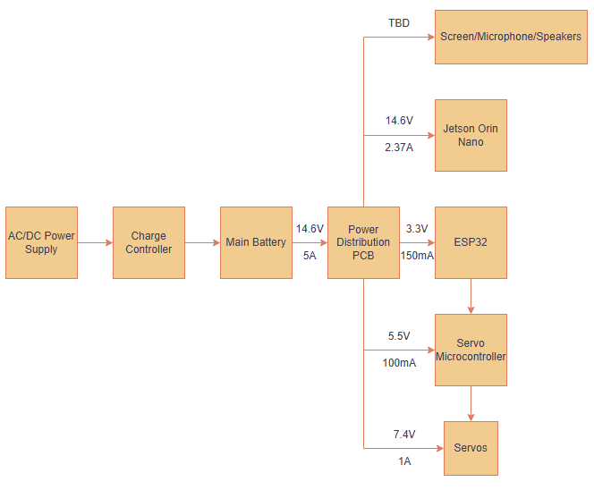
Figure 2: Electrical Interface Diagram

Primary Input Power

5.1.1 Main Power System
The Autonomous University Robot Assistant (ARUA) will be powered by a 14.6V 4-cell Li-Po battery pack rated at 5000 mAh. This battery will supply sufficient energy for several hours of continuous lab use. The power distribution system uses step-down regulators to provide 5V for servo motors, 14.6V for the Jetson Orin Nano, and 3.3V for the ESP32 and sensor interfaces.

5.1.2 Charging and Protection
An inline fuse and polarity protection circuitry are implemented to prevent damage from accidental miswiring. Battery management modules will regulate charging to ensure safe operation during repeated lab use.

User Control Interface
The user will interact with ARUA through a touchscreen interface powered by the Jetson Orin Nano. A physical emergency stop button is integrated into the chassis, providing immediate cutoff of motor power in case of malfunction. In addition, remote access is available through a web dashboard when the system is connected to Wi-Fi.

Voltage and Current Levels

5.3.1 Maximum Values
Component | Voltage (V) | Current (A) | Power (W)
Jetson Orin Nano | 14.6 | 2.37 | 34.6
ESP32 | 3.3 | 500 | 1.76
Servo Motor  (per unit) | 7.4 | 0.1 | 0.74W
Touchscreen Display | TBD | TBD | TBD
Microphone | TBD | TBD | TBD
Speaker | TBD | TBD | TBD
Table 9: Maximum Voltage and Current Levels

The values in this table represent peak load conditions. These are expected only during periods of maximum computation (Jetson), simultaneous servo movement, and display usage.

5.3.2 Stand-by Values
Component | Voltage (V) | Current (A) | Power (W)
Jetson Orin Nano | 7 | 1 | 7.95
ESP32 | 3.3 | 150 | 0.5
Touchscreen Display | TBD | TBD | TBD
Microphone | TBD | TBD | TBD
Speaker | TBD | TBD | TBD
Table 10: Stand-by Voltage and Current Levels

The standby values represent average consumption under idle or low-demand operation, estimated at roughly 60–70% of total usage.

5.4 Signal Interfaces

5.3.1 PWM Motor Control
Servo motors are driven via PWM signals generated by the ESP32 and routed through motor control expansion boards. Each PWM line is isolated and regulated to prevent signal distortion.

Communications / Device Interface Protocols

Wireless Communications

6.1.1. Wi-Fi
The ESP32 provides IEEE 802.11 b/g/n Wi-Fi connectivity, enabling communication with the Jetson Orin Nano and external lab networks. This allows ARUA to interface with cloud services, local data servers, and remote terminals for monitoring.

6.1.2. Bluetooth
The ESP32 includes Bluetooth 4.2/5.0 support for optional low-power communication with external devices such as smartphones, tablets, or Bluetooth-enabled lab instruments.

Host Device
The Jetson Orin Nano includes multiple USB 3.0 ports used for connecting peripherals such as a keyboard, mouse, or debugging interface. These ports also support USB-to-serial adapters for direct sensor integration.

Video Interface
The Jetson Orin Nano provides HDMI 2.0 output to drive the integrated touchscreen display. An external monitor may also be connected for demonstrations or lab presentations.

Device Peripheral Interface
Communication between the ESP32 and Jetson Orin Nano is handled via UART, using a custom JSON-based protocol. I²C buses are available for ADC expansion modules and future sensor add-ons, while GPIO pins provide interrupt-driven input from user switches and lab safety sensors.

Audio and Vision Interface

Overview
The Audio and Vision Interface defines the data, signal, and software connections between the Jetson Orin Nano processing unit, the microphone/speaker array, and the camera subsystem. These interfaces enable real-time speech recognition (STT), text-to-speech (TTS) synthesis, multilingual translation, image-to-text processing, and multimodal fusion for question-answering.

Speech Interface

7.2.1. Input Hardware
Dual digital MEMS microphones connected via USB audio interface to the Jetson Orin Nano.

7.2.2. Output Hardware
4 Ω / 3 W speaker-amplifier module powered from the 5 V rail of the Power PCB.

7.2.3. Software Stack
OpenAI Whisper STT engine → Local LLM + RAG backend → TTS synthesis (via Coqui TTS or PyTorch Vocoder).

7.2.4. Signal Path
Signal Path:
- Analog audio → ADC (USB audio codec) → Jetson audio driver → Whisper STT.
- AI response → TTS engine → DAC → amplifier → speaker output.

7.2.5. Data Format
16-bit PCM, 44.1 kHz sampling rate.

7.2.6. Latency Requirement
End-to-end (STT→LLM→TTS) response ≤ 1.0 s for typical single-sentence queries.

Censorship and Translation Layer

7.3.1. Censorship
Real-time lexical filter applied post-STT; profanity or restricted terms are masked before forwarding to the LLM.

7.3.2. Translation
Integrated multilingual model detects language from STT output and performs automatic translation to English (or maintains native language for echo playback).

7.3.3. Interface Dependency
Operates entirely in software on the Jetson CPU / GPU; no additional hardware interface required.

7.3.4. Database Logging
Filtered and translated transcripts stored in the local SQLite database with timestamps.

Vision Interface

7.4.1. Input Hardware
8 MP CSI or USB camera connected to Jetson Orin Nano.

7.4.2. Processing Stack
Segment Anything Model (SAM 2) + OpenCV + local LLM for image captioning and contextual query interpretation.

7.4.3. Multimodal Fusion
STT text and image embedding combined through LLM token alignment to support speech + image questions.

7.4.4. Output
Textual or spoken AI response rendered via TTS module and UI display.

7.2.5. Frame Format
YUV or RGB 640 × 480 minimum, 30 FPS.

Communication Interfaces

7.5.1. Jetson ↔ ESP32
UART (JSON commands) for voice-triggered robotic actions

7.5.2. Jetson ↔ Database
Local SQLite or MySQL API for speech and image logs.

7.5.3. Jetson ↔ Tablet/Web UI
WebSocket or REST API for live speech display, translation mode toggle, and audio control.

Environmental and Electrical Parameters
Parameter | Value / Range | Notes
Microphone Operating Voltage | 5 V DC | Draw < 50 mA per channel
Speaker Amplifier Voltage | 5 V DC | Peak 1 A draw under speech output
Camera Input Voltage | 5 V DC | < 200 mA draw
Audio Signal Type | Digital PCM USB | Isolated from main power noise
Operating Temperature | 0–45 °C | Lab ambient conditions

